**City of Auburn Great American Cleanup**

**Friday March 28th. 8:00 a.m. – 4:30 p.m.**

**Saturday March 29th. 8:00 a.m.– 12:00 p.m.**



**We will be collecting:**

**Batteries**

**Motor Oil**

**Scrap Metal**

**Electronics (Flat Panels TVs Accepted)**

**Plastics**

**Freon Free Appliances Wood (no construction)**

**Tires – limit 2 No Charge**

**After that the charge is $5.00 for Standard**

**Rims and Tractor tires $8.00 each**

**WE CANNOT ACCEPT:**

**Paint of Any Type**

**Paint Thinner**

**No Household / Municipal Garbage**

**No Chemicals**

**Yard Waste**

**Construction Material**

**All loose items must be boxed or bagged**

**NO EXCEPTIONS!!!**

**Containers will be set up at Mary Carter Ballfields**

**1320 Mary Carter Road Auburn**

**For more information contact Joe Moravec**

[**jmoravec@cityofauburn-ga.org**](mailto:jmoravec@cityofauburn-ga.org)

**770-963-4002 Ext. 331**

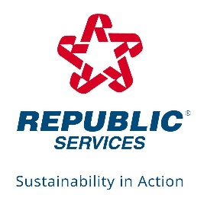**SPECIAL THANKS TO SPONSOR:**